Python Master course

Where it is used...?
1.Interview
2.Day to day work in office

But mostly used in Interview only

Before going interview practive leet code, but leetcode is not mandatory

1.Mindset
2.No confusion
3.Un Learn ->forgot which you previously learned then only you can learn it other wise it will distrub you
4.dont study with stress and dont streesed to study

Programming vs coding

Coding: it is a set of instructions
Programming : architecure,design,coding,debug ,testing

Python Histroy

- Feb 20 1991 -> netherland ,python version 0.9.0
- inspired by abc language
- Monty flying circus python -> name
Where we use python
- Automation
- Scheduling
- Data processing
- Software development(mobileappication, web application, system application)
- IOT devices
- Problem solving
Three types of programming
procedural programming -> all programming oridented basically
object oriented programming ->
functional programming

Python is procedural and object oriented and functinal programming ( java and C++ also)
c is a proceudral programming
Frameworks developed using python
numpy
pandas
pytest
flask
tensor flow
hy and myhdl programming language create by using python

youtube ,reddit are using python

spark is frame work which is created by java , we can use python to code it in.

First always learn frameworks

Open source:

Every one can access and edit the code
you can get lisence for your code(apace, free software foundation)

you can get famous and get reputation from big companies

contributor – who make changes in someones framework or code

How your computer understand code

computer basically understand 0s and 1s only

Low level language – assembly and machine code
High level language – java, python and c++

Python internals
PVM
(Python virtual machine)
ex in C language
Source code ------> compiler -------> Machine code

In python
Compiler
Run time
Compile time
Machine
code
Intermediate code
Source code

Platform: Os + process(linux + amd Processor)

python is platform independant

Source code --->compiler ---->bytecode---->pvm---->machine code

Compiler is platform dependant

IDE-Intergragted developed environment

REPL – Read Evaluate Print loop (which is the ptyhon IDE)
we can use pycharm and vs code also

PEP 8 :

🐍 What is PEP 8?
PEP 8 stands for Python Enhancement Proposal 8.
It is the official style guide for Python code, written by Guido van Rossum (Python's creator) and others.

📘 Purpose of PEP 8:
- ✅ Make Python code readable, consistent, and professional
- ✅ Help teams collaborate with uniform code style
- ✅ Make it easier to debug, maintain, and scale code

📌 PEP 8 Covers:
Area | Guideline Example
Indentation | Use 4 spaces per level (❌ No tabs)
Line Length | Limit lines to 79 characters
Blank Lines | Use blank lines to separate functions/classes
Imports | Import standard libraries first, then third-party
Naming Conventions | snake_case for variables/functions, CamelCase for classes
Spaces in Expressions | Use spaces around operators: x = a + b
Function Definitions | Leave a space after comma: def func(a, b):
Docstrings | Use """triple quotes""" for documentation
Comments | Write meaningful, grammatically correct comments

🔍 Example:

# ✅ PEP 8 compliant
def add_numbers(a, b):
"""Add two numbers and return the result."""
return a + b

# ❌ Not PEP 8 compliant
def addnumbers(a,b): return a+b

Indentation is must here because we dont have bracket here

🐍 Python Indentation — Explained Clearly
In Python, indentation is not optional — it defines the structure of the code.
Unlike C, Java, or other languages that use {} for code blocks, Python uses indentation (spaces or tabs) to indicate blocks like if, for, while, functions, etc.

✅ Basic Rule:
Use 4 spaces per indentation level (as recommended by PEP 8).

📌 Example:

# Correct indentation
def greet(name):
if name:
print("Hello", name)
else:
print("Hello, Stranger!")

# ❌ Incorrect (inconsistent indentation)
def greet(name):
if name:
print("Hello", name)
else:
print("Hello, Stranger!")
That second example will throw:

IndentationError: unindent does not match any outer indentation level

🔹 Where Indentation is Required:
Statement Type | Requires Indented Block Below?
if, elif, else | ✅ Yes
for, while | ✅ Yes
def, class | ✅ Yes
try, except, finally | ✅ Yes
Functions and methods | ✅ Yes

⚠️ Common Indentation Errors:
Error | Description
IndentationError | You used the wrong indentation level.
TabError | You mixed tabs and spaces (don't do this!).
✅ Always use spaces, never tabs. Set your editor (like VS Code or Geany) to insert 4 spaces instead of tabs.

Variables and Data types

🔹 1. What is a Variable in Python?
A variable is just a name you give to a value stored in memory. You use it to store and work with data in your programs.

✅ Example:

name = "Panjatcharam"
age = 23
Here:
- name is a variable holding a string value
- age is a variable holding a number
🧠 Think of variables as labeled boxes where you can put data and use it later.

🔹 2. Python is Dynamically Typed
✅ You don’t need to declare a variable type — Python figures it out based on the value.

x = 10 # Integer
x = "hello" # Now it's a string!

🔹 3. Basic Data Types in Python

🔸 a. int — Integer (whole number)

a = 10

🔸 b. float — Decimal numbers (floating-point)

pi = 3.14

🔸 c. str — String (text)

name = "John"

🔸 d. bool — Boolean (True or False)

is_valid = True

🔹 4. Collection Data Types

🔸 a. list — Ordered collection of items (can be of different types)

my_list = [1, 2, 3, "hello"]

🔸 b. tuple — Like list, but immutable (cannot change it)

my_tuple = (1, 2, 3)

🔸 c. set — Unordered, unique items only

my_set = {1, 2, 2, 3}
# Output: {1, 2, 3}

🔸 d. dict — Dictionary (key-value pairs)

person = {"name": "Alice", "age": 30}

🔹 5. How to Check the Type of a Variable
Use the type() function:

x = 10
print(type(x)) # <class 'int'>

🔹 6. Type Conversion (Casting)
You can convert one type to another:

# String to int
num = int("123")

# Int to string
s = str(123)

# Float to int
a = int(3.99) # result: 3 (no rounding)

🔹 7. Naming Rules for Variables
✅ Valid:
- my_name
- age1
- _counter
❌ Invalid:
- 1name (cannot start with a number)
- my-name (no hyphens)
- class (reserved keyword)

🧠 Tip to Remember Data Types:
Type | Example | Used For
int | 10, -5 | Whole numbers
float | 3.14, -2.7 | Decimals
str | "hello" | Text
bool | True, False | Logic / Conditions
list | [1, "two"] | Ordered collection
tuple | (1, 2) | Ordered + Immutable list
set | {1, 2, 3} | Unique items
dict | {"a": 1} | Key-value pairs

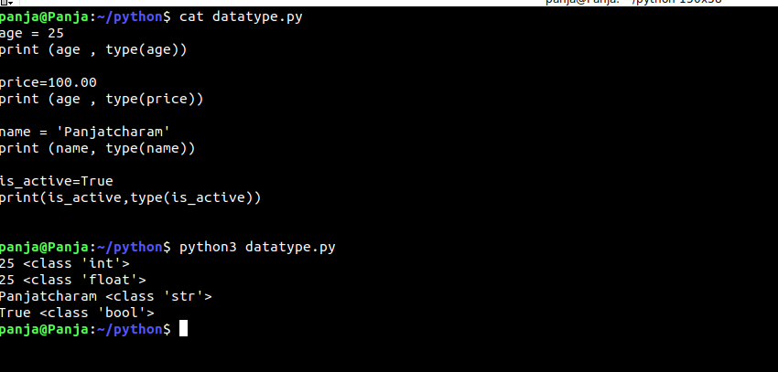
Python scope and Variable scope or life type

L -> E -> G -> B
L – local
E - Enclosing
G - Global
B -Builtin

🧠 1. What is Scope in Python?
Scope defines where a variable can be accessed or used in your code.
Python has four levels of scope:
Scope Type | Description | Example
Local | Inside a function | def func(): x = 5
Enclosing | Inside nested functions | A function inside a function
Global | Defined at top level (outside all functions) | x = 10 outside any function
Built-in | Predefined by Python | print(), len(), etc.
This is known as the LEGB Rule:
Local → Enclosing → Global → Built-in

🔹 Example:

x = "global" # Global Scope

def outer():
x = "enclosing" # Enclosing Scope
def inner():
x = "local" # Local Scope
print(x)
inner()

outer() # Output: local
Python looks for x in Local → Enclosing → Global → Built-in.

🕰️ 2. What is Variable Lifetime?
Lifetime refers to how long a variable exists in memory.

🔹 Rules:
Variable Scope | Lifetime Ends When...
Local | Function finishes
Global | Program ends

✅ Example:

def my_func():
a = 10 # 'a' is created when function runs
print(a)

my_func()
print(a) # ❌ Error: 'a' no longer exists

🔧 3. global Keyword
If you want to modify a global variable inside a function, use global.

x = 5

def change():
global x
x = 10

change()
print(x) # Output: 10

🔧 4. nonlocal Keyword
Use nonlocal to change enclosing variables inside nested functions.

def outer():
x = "outer"
def inner():
nonlocal x
x = "inner"
inner()
print(x)

outer() # Output: inner

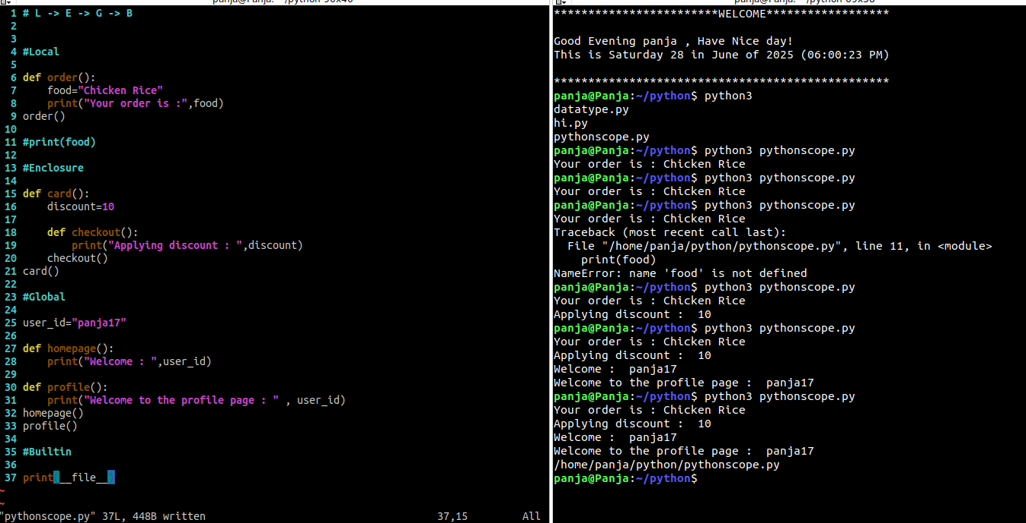
✅ Summary Chart:
Scope | Where it is defined | Lifetime Ends | Accessed Using
Local | Inside a function | When function exits | Directly inside function
Enclosing | In enclosing (outer) function | When outer function exits | nonlocal
Global | Top-level code | Program ends | global
Built-in | Python system scope | Always available | Direct access (print())
print(f-> this is the f string)
🔧 There should be no space between f and the opening double-quote ".

🔍 Explanation:
- f"..." is how you write formatted strings in Python.
- Variables inside {} get evaluated and replaced with their values.
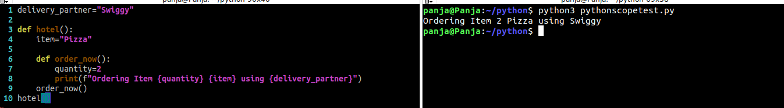
Type Casting & checking:

x =”10”

print(type(x))

output is <class ‘str’)

🔹 What is Type Casting in Python?
Type casting means converting one data type to another, like string to int, float to int, etc.

✅ Common Type Casting Functions:
Function | Converts to... | Example
int(x) | Integer | int("10") → 10
float(x) | Float | float("3.14") → 3.14
str(x) | String | str(123) → "123"
bool(x) | Boolean | bool(0) → False, bool("Hello") → True
list(x) | List | list("abc") → ['a', 'b', 'c']
tuple(x) | Tuple | tuple([1, 2]) → (1, 2)
set(x) | Set | set([1, 1, 2]) → {1, 2}

🔸 Examples:

a = "100"
b = int(a) # 'b' is now 100 (integer)

x = 3.7
y = int(x) # y = 3 (decimal removed)

z = str(45.6) # z = "45.6"

🔹 What is Type Checking?
You check what data type a variable is using the type() function.

✅ Example:

x = 10
print(type(x)) # <class 'int'>

y = "hello"
print(type(y)) # <class 'str'>

🔸 Check if variable is a specific type using isinstance()

✅ Syntax:

isinstance(variable, type)

✅ Example:

a = 5
print(isinstance(a, int)) # True
print(isinstance(a, str)) # False

b = [1, 2, 3]
print(isinstance(b, list)) # True

🔁 Quick Summary Table
Task | Syntax | Example Result
Convert to int | int("42") | 42
Convert to float | float("3.5") | 3.5
Convert to string | str(100) | "100"
Check data type | type(x) | <class 'int'>
Check exact type | isinstance(x, int) | True / False

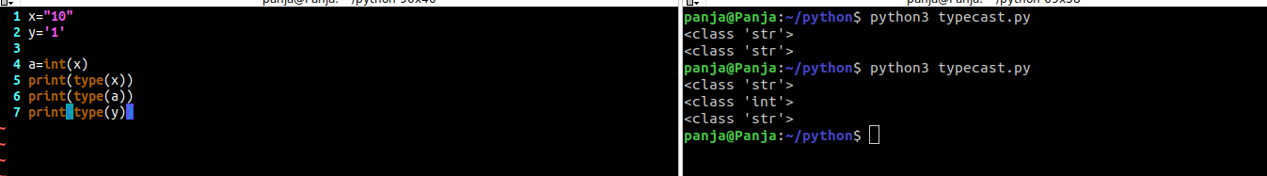
basic type casting

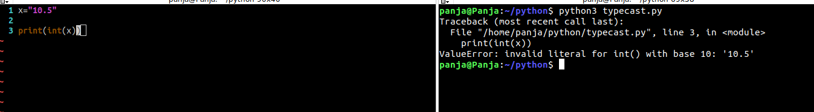
We can only change from their orginal data type only other it will show error
Corrected conversion:

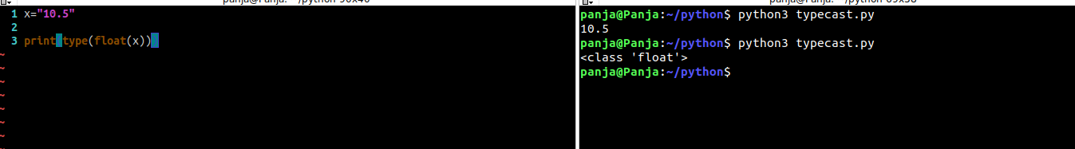

🔹 1. Arithmetic Operators
Used for basic math operations.
Operator | Description | Example | Output
+ | Addition | 5 + 2 | 7
- | Subtraction | 5 - 2 | 3
* | Multiplication | 5 * 2 | 10
/ | Division (float) | 5 / 2 | 2.5
// | Floor Division | 5 // 2 | 2
% | Modulus (remainder) | 5 % 2 | 1
** | Exponent (power) | 2 ** 3 | 8

🔹 2. Comparison Operators (Relational)
Used to compare values. Returns True or False.
Operator | Meaning | Example | Output
== | Equal to | 5 == 5 | True
!= | Not equal to | 5 != 3 | True
> | Greater than | 5 > 2 | True
< | Less than | 5 < 2 | False
>= | Greater or equal | 5 >= 5 | True
<= | Less or equal | 5 <= 3 | False

🔹 3. Assignment Operators
Used to assign values to variables.
Operator | Example | Equivalent To
= | x = 5 | assign 5 to x
+= | x += 3 | x = x + 3
-= | x -= 3 | x = x - 3
*= | x *= 3 | x = x * 3
/= | x /= 3 | x = x / 3
//= | x //= 3 | x = x // 3
%= | x %= 3 | x = x % 3
**= | x **= 3 | x = x ** 3

🔹 4. Logical Operators
Used to combine conditions.
Operator | Description | Example | Result
and | True if both are True | x > 5 and x < 10 | True/False
or | True if one is True | x > 5 or x < 2 | True/False
not | Reverses the condition | not(x > 5) | True/False

🔹 5. Bitwise Operators (work at binary level)
Operator | Meaning | Example | Result
& | AND | 5 & 3 | 1
` | ` | OR | `5
^ | XOR | 5 ^ 3 | 6
~ | NOT | ~5 | -6
<< | Left Shift | 5 << 1 | 10
>> | Right Shift | 5 >> 1 | 2

🔹 6. Membership Operators
Used to test if a value exists in a sequence (like string, list, etc.).
Operator | Example | Result
in | "a" in "apple" | True
not in | "x" not in "apple" | True

🔹 7. Identity Operators
Compare memory location of two variables.
Operator | Example | Result
is | a is b | True if both point to same object
is not | a is not b | True if different objects

🔍 Quick Practice Example:

a = 10
b = 5

print(a + b) # 15 (Arithmetic)
print(a > b) # True (Comparison)
print(a != b) # True
print(a > 5 and b < 10) # True (Logical)
print(a & b) # 0 (Bitwise)
print("a" in "apple")# True (Membership)

Basic operators example

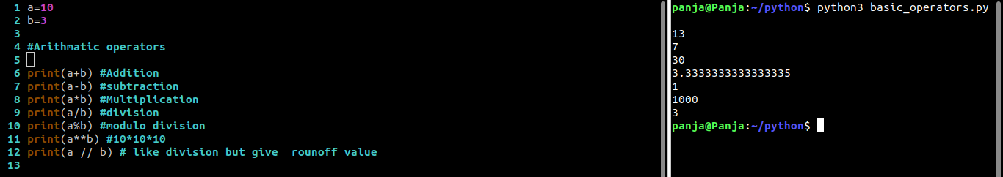

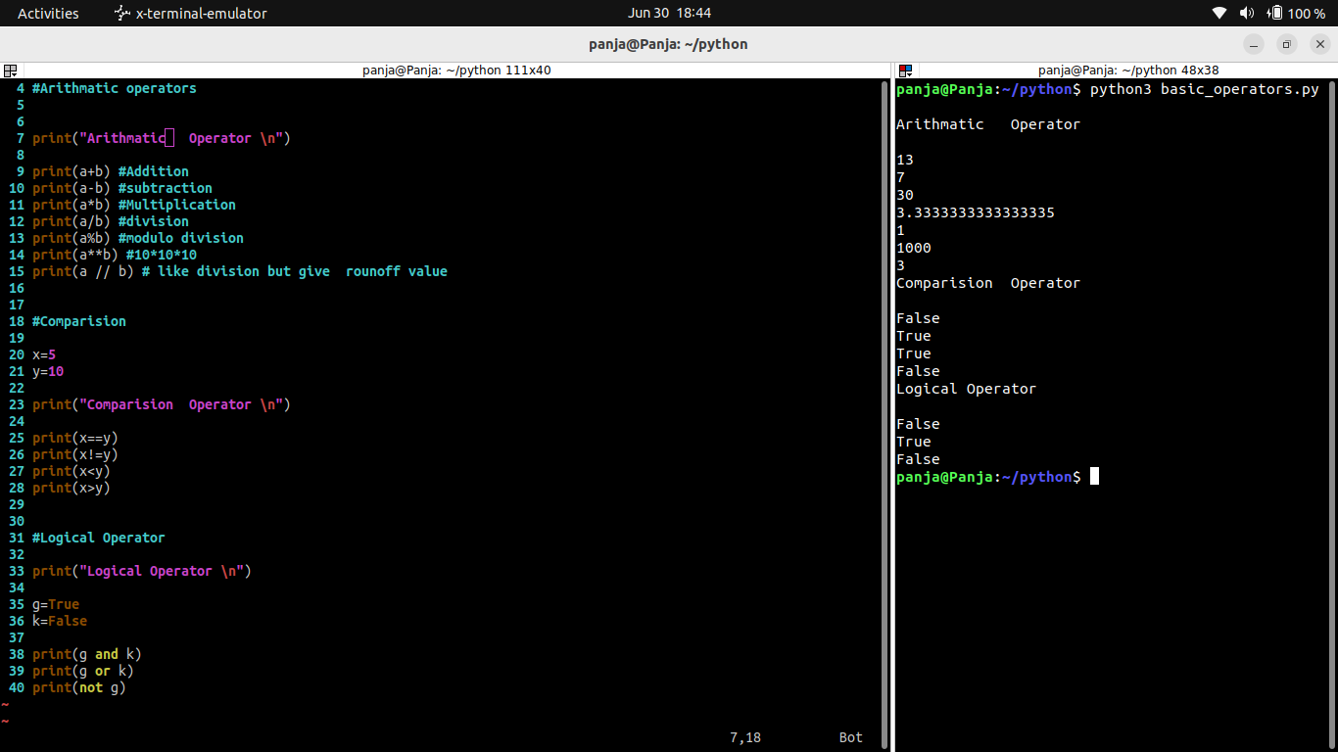

colon is must here because we dont have bracket
if ahfkjsd :

total-=discount --> total = total - discount
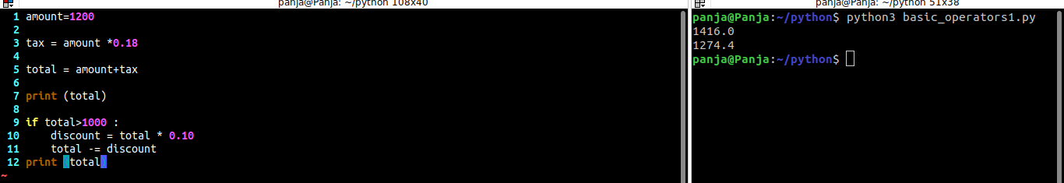
discount program example:
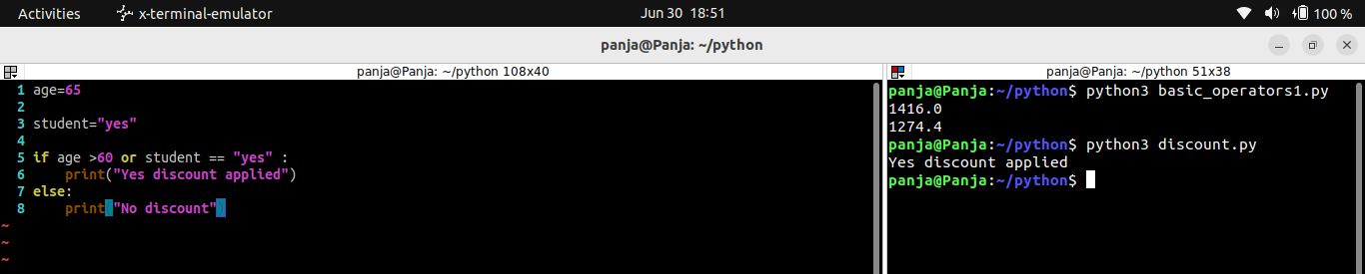
Commenting in python:

# is used to comment the line

this is called single line commenting

“”” - > three times double quotes means this is multi line commenting
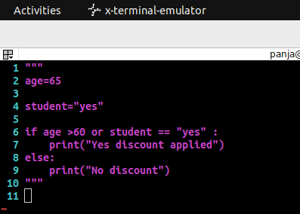

we can use single quotes also
‘’’ but we need to give three times

🔹 Single-line Comments
- Begin with a # symbol.
- Everything after # on that line is considered a comment.
python
CopyEdit
# This is a single-line comment
x = 10 # This comment is next to code

🔹 Multi-line Comments (Using #)
- There's no special multi-line comment syntax in Python like /* */ in C.
- You can write multiple # lines:
# This is a multi-line comment
# explaining the next block of code
for i in range(5):
print(i)

🔹 Docstrings (for documentation)
- These are string literals used to document functions, classes, or modules.
- Use triple quotes (""" """ or ''' ''').
- Can span multiple lines.
def greet(name):
"""
This function greets the person
passed as an argument.
"""
print(f"Hello, {name}!")

INPUT HANDLING(sys.argv)

hard coding is not preferred -> data given in the code itself

🔹 What is sys.argv?
- sys.argv is a list in Python that contains the command-line arguments passed to the script.
- You need to import the sys module to use it.
import sys
- sys.argv[0] is the name of the script.
- sys.argv[1], sys.argv[2], etc., are the additional arguments.

🔹 Example
Let's say we create a script called greet.py:
# greet.py
import sys

name = sys.argv[1] # First command-line argument
print(f"Hello, {name}!")
Then run it from the command line:

python greet.py Alice
Output:
Hello, Alice!

🔹 Multiple Arguments Example

# add.py
import sys

# Convert arguments to integers and sum them
numbers = list(map(int, sys.argv[1:])) # Skip the script name
total = sum(numbers)
print("Total:", total)
Command to run:

python add.py 10 20 30
Output:

Total: 60

🔹 Error Handling with sys.argv
Always check if enough arguments are passed:

import sys

if len(sys.argv) < 3:
print("Usage: python script.py arg1 arg2")
sys.exit(1)

arg1 = sys.argv[1]
arg2 = sys.argv[2]
print("Arguments received:", arg1, arg2)

✅ Best Practices
- Use sys.argv when the script is meant to be run from the terminal.
- For large scripts, consider using argparse (more flexible and user-friendly).
- Always validate and sanitize input.

Getting input from user
we need to do type cast for the integer values
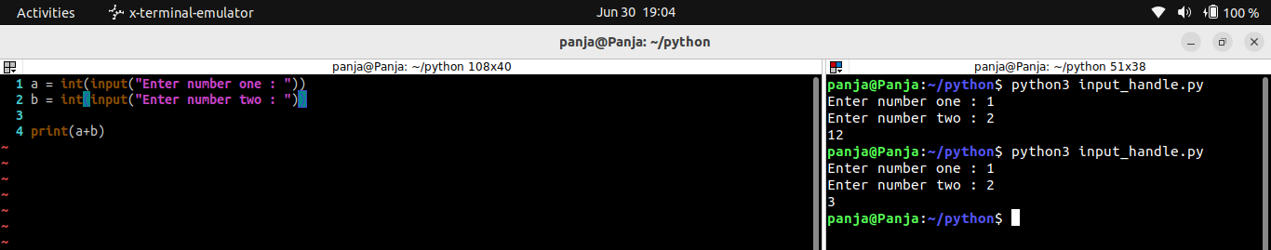
sys.argv->system argument
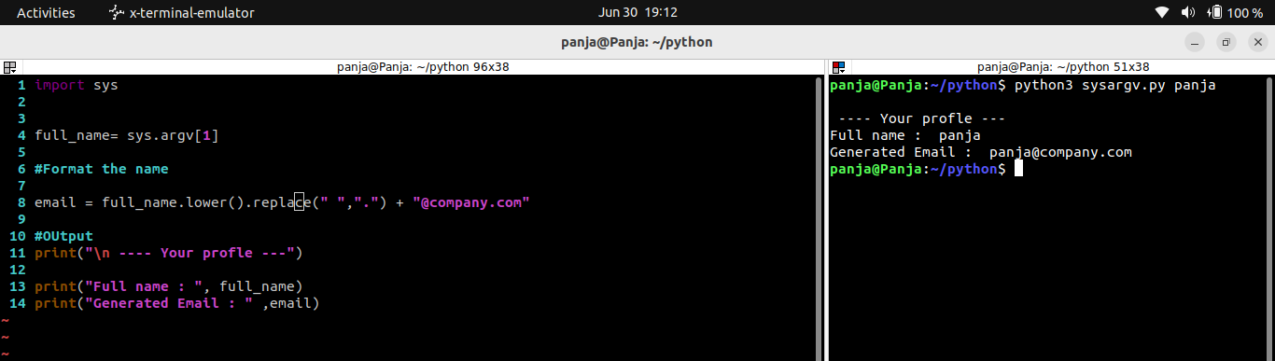

Sys argv[0] ->script file name
other files are 1,2,...,etc

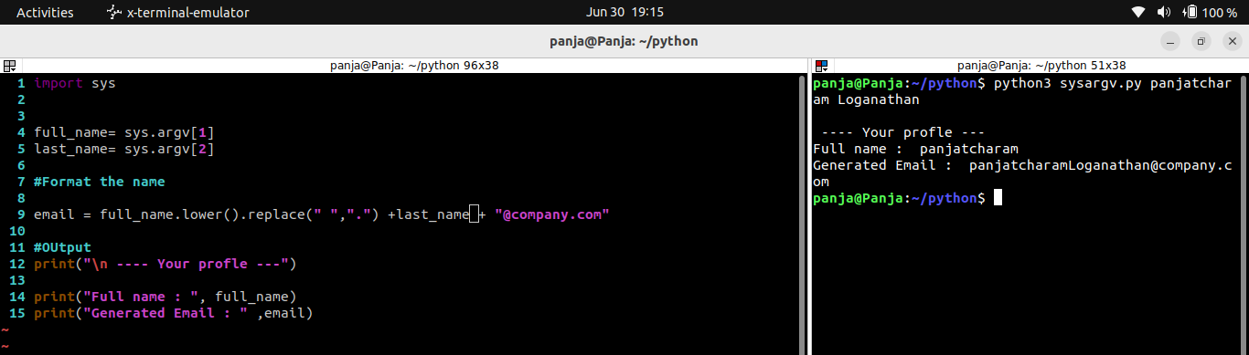
error handlingin python
if len(sys.argv) ==2:
print("Usage python3 sysargv.py 'Fullname and last name'")
sys.exit()
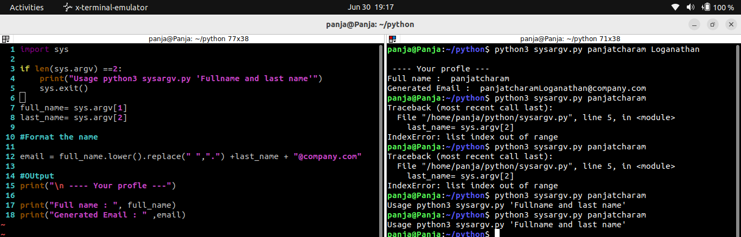

full name = sys.argv[1:]

it will take the other strings as a single input

to avoid the string issue
full_name = “ “.join(sys.argv[1:])
print(full_name)
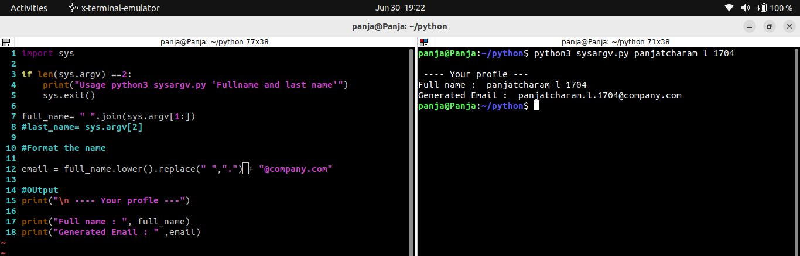

Strings in Python

anything written in single quotes or double quotes are called as string.
It can be anything (int,float,abc,number etc)
example:
driver_name = "Panja"

print(driver_name.lower()) # convert all to lower
print(driver_name.upper()) #convert all to upper
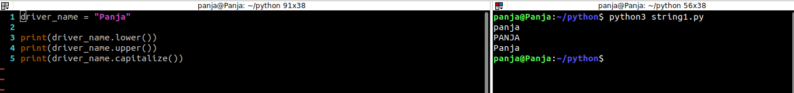
print(driver_name.capitalize()) # convert first letter to upper

🧵 What is a String in Python?
A string is a sequence of Unicode characters. Strings are immutable in Python (they cannot be changed after creation).

text = "Hello, World!"

✂️ String Manipulation in Python

🔹 1. Concatenation (Joining strings)

a = "Hello"
b = "World"
c = a + " " + b
print(c) # Output: Hello World

🔹 2. Repetition
msg = "Hi! "
print(msg * 3) # Output: Hi! Hi! Hi!

🔹 3. Slicing and Indexing

s = "Python"
print(s[0]) # Output: P
print(s[-1]) # Output: n
print(s[1:4]) # Output: yth
print(s[:]) # Output: Python (full string)

🔹 4. String Length
name = "Sarath"
print(len(name)) # Output: 6

🔹 5. Changing Case

text = "python"
print(text.upper()) # PYTHON
print(text.capitalize()) # Python
print("HELLO".lower()) # hello

🔹 6. Remove Whitespace

msg = " Hello World "
print(msg.strip()) # Removes both sides
print(msg.lstrip()) # Removes left side
print(msg.rstrip()) # Removes right side

🔹 7. Replace Substring

sentence = "I love coffee"
print(sentence.replace("coffee", "tea")) # I love tea

🔹 8. Split and Join

# Split
data = "one,two,three"
parts = data.split(",")
print(parts) # ['one', 'two', 'three']

# Join
joined = "-".join(parts)
print(joined) # one-two-three

🔹 9. Check Substring (in operator)

text = "This is Python"
print("Python" in text) # True
print("Java" not in text) # True

🔹 10. Find and Count

text = "banana"
print(text.find("a")) # First 'a' at index 1
print(text.count("a")) # 3 times

🔹 11. String Formatting

name = "Sarath"
age = 25

# Using f-strings
print(f"My name is {name} and I'm {age} years old.")

# Using .format()
print("My name is {} and I'm {} years old.".format(name, age))

🔹 12. Escape Sequences

print("Line1\nLine2") # New line
print("Tab\tSpace") # Tab space
print("He said \"Hi\"") # Double quote inside string

🔹 13. Multiline Strings

quote = """This is
a multiline
string."""
print(quote)

🔹 14. String Validation Methods
Method | What it checks for
isalnum() | Only alphanumeric characters
isalpha() | Only letters
isdigit() | Only digits
islower() | All lowercase
isupper() | All uppercase
isspace() | Only whitespace
startswith() | Starts with substring
endswith() | Ends with substring

s = "Python3"
print(s.isalnum()) # True

✅ Summary: Common Use Cases
Task | Function / Method
Combine strings | + or join()
Break string into words | split()
Remove unwanted characters | strip(), replace()
Extract part of a string | Slicing text[start:end]
Change case | upper(), lower()
Find/Count words | find(), count()

🛠 Real-World Example

user_input = " Hello, my name is SARATH "
cleaned = user_input.strip().capitalize()
if "sarath" in cleaned.lower():
print(f"Welcome, {cleaned}")

Example of masked mobile number program
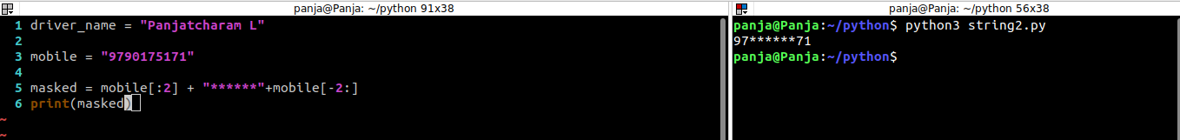
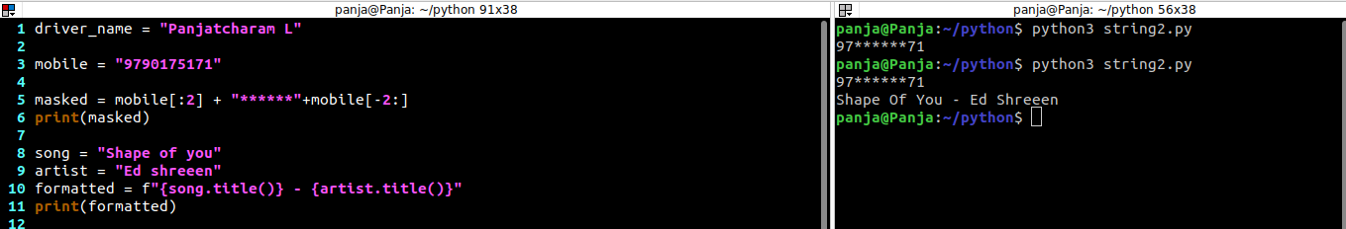
Uber booking example

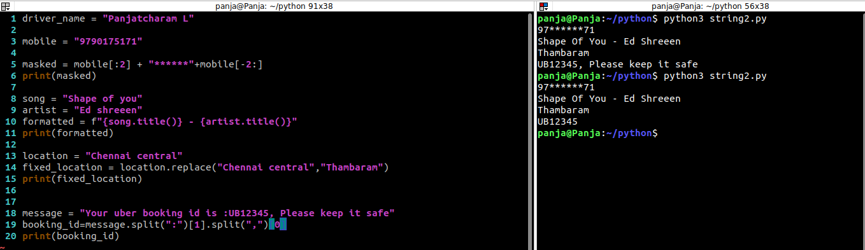

✅ Real-World String Examples

🔹 1. Validating Email Address Format (Basic Check)

email = "test@example.com"

if "@" in email and "." in email:
print("Valid email")
else:
print("Invalid email")
✅ Use case: Check email format during user registration.

🔹 2. Extracting Domain from an Email Address

email = "user@company.com"
domain = email.split("@")[1]
print(domain) # Output: company.com
✅ Use case: Logging or grouping emails by domain.

🔹 3. Capitalizing First Letter of Each Sentence

msg = "python is fun. it is easy to learn."
sentences = msg.split(". ")
capitalized = ". ".join(sentence.capitalize() for sentence in sentences)
print(capitalized)
# Output: Python is fun. It is easy to learn.
✅ Use case: Formatting text before sending an email or message.

🔹 4. Hiding Part of an Email (Privacy Masking)

email = "panjatcharam@gmail.com"
masked_email = email[0] + "*****" + email[email.index("@"):]
print(masked_email) # Output: p*****@gmail.com
✅ Use case: Show masked info in UI without revealing full details.

🔹 5. Extracting File Extension from Filename

filename = "report.xlsx"
extension = filename.split(".")[-1]
print(extension) # Output: xlsx
✅ Use case: Validate file types during upload.

🔹 6. Creating a URL Slug from a Blog Title

title = "Python String Functions Explained"
slug = title.lower().replace(" ", "-")
print(slug) # Output: python-string-functions-explained
✅ Use case: Convert blog or page titles into URL-friendly slugs.

🔹 7. Check if Password is Strong (Simple Check)
python
CopyEdit
password = "Code@123"

if len(password) >= 8 and any(c.isupper() for c in password) and any(c.isdigit() for c in password) and any(c in "@#$%" for c in password):
print("Strong Password")
else:
print("Weak Password")
✅ Use case: Password strength checker in signup forms.

🔹 8. Extract Hashtags from a Social Media Post
python
CopyEdit
post = "Loving the new features in #Python #AI #Automation"
hashtags = [word for word in post.split() if word.startswith("#")]
print(hashtags) # Output: ['#Python', '#AI', '#Automation']
✅ Use case: Hashtag analysis in social media automation.

🔹 9. Format Amounts with Comma Separators
python
CopyEdit
amount = 1500000
formatted = "{:,}".format(amount)
print(formatted) # Output: 1,500,000
✅ Use case: Display large numbers in readable format.

🔹 10. Dynamic Message Generation
python
CopyEdit
name = "Sarath"
product = "iPhone"
msg = f"Hi {name}, your {product} is ready for pickup!"
print(msg)
✅ Use case: Notifications, auto-replies, chatbot replies.

🔹 11. Clean Text from Unwanted Characters
python
CopyEdit
raw = "Hello!!! This is @@Python$$"
cleaned = ''.join(c for c in raw if c.isalnum() or c.isspace())
print(cleaned) # Output: Hello This is Python
✅ Use case: Preprocessing text data (e.g., for ML or reports).

🔹 12. Shortening a String for UI Display
python
CopyEdit
description = "This is a long text that we want to shorten..."
short = description[:30] + "..." if len(description) > 30 else description
print(short)
✅ Use case: Truncate product descriptions in cards or table views.

🔹 13. Get Only Digits from a String
python
CopyEdit
input_str = "Order #12345 has been shipped."
digits = ''.join(c for c in input_str if c.isdigit())
print(digits) # Output: 12345
✅ Use case: Extract numeric IDs from text.

🔹 14. Highlighting Words in Terminal
python
CopyEdit
text = "Error: Temperature threshold exceeded"
highlight = text.replace("Error", "\033[91mError\033[0m")
print(highlight)
✅ Use case: CLI alerts using ANSI color codes.

🔹 15. Reverse a String
text = "Python"
print(text[::-1]) # Output: nohtyP
✅ Use case: Palindrome checking, data reversal.
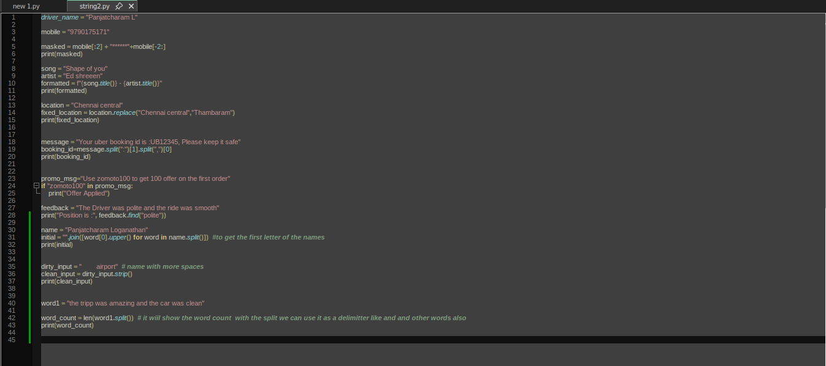
OUTPUT:

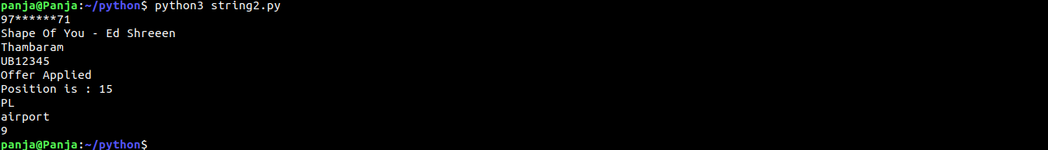

CONDITIONAL STATEMENTS:
Conditional statements in Python are used to make decisions based on certain conditions. They allow your program to take different paths depending on whether a condition is True or False.

🔹 1. if Statement

x = 10

if x > 5:
print("x is greater than 5")
✅ Explanation: If the condition x > 5 is True, the indented block is executed.

🔹 2. if...else Statement

x = 3

if x > 5:
print("x is greater than 5")
else:
print("x is not greater than 5")
✅ Explanation: If x > 5 is False, the else block runs.

🔹 3. if...elif...else Ladder
python
CopyEdit
x = 0

if x > 0:
print("Positive number")
elif x == 0:
print("Zero")
else:
print("Negative number")
✅ Explanation:
- Checks the conditions one by one.
- Executes the first block where the condition is True.

🔹 4. Nested if Statements
python
CopyEdit
x = 15

if x > 10:
if x < 20:
print("x is between 10 and 20")
✅ Explanation: One if inside another to check more specific conditions.

🔹 5. Ternary Operator (One-liner if)

x = 7
result = "Even" if x % 2 == 0 else "Odd"
print(result)
✅ Explanation: Compact form of if...else used for assignment.

🔹 6. Logical Operators in Conditions

age = 25

if age > 18 and age < 60:
print("Working age")
You can use:
- and → both conditions must be True
- or → at least one must be True
- not → negates the condition

Summary Table
Statement Type | Syntax Example
Simple if | if x > 5:
if...else | if x > 5: ... else:
if...elif...else | if x > 0: ... elif x == 0: ... else:
Nested if | if x > 10: if x < 20:
Ternary Expression | result = "A" if x > 5 else "B"

IF and if else condition:
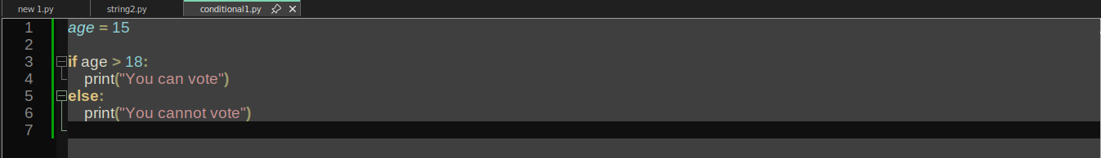
Nested IF
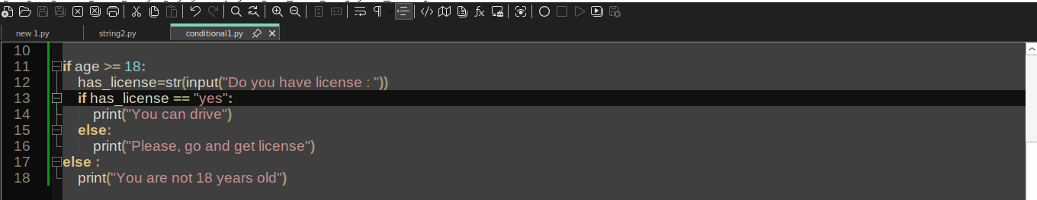

🔹 in Keyword in Python
The in keyword in Python is used to check membership — i.e., whether a value exists in a sequence (like a list, string, tuple, set, or dictionary).

✅ Basic Syntax

value in collection
Returns True if the value is found in the collection, otherwise False.

🔹 1. Using in with Strings

text = "hello world"

if "world" in text:
print("Yes, 'world' is in the text")
📌 Explanation: Checks if substring "world" is in the main string.

🔹 2. Using in with Lists

fruits = ["apple", "banana", "cherry"]

if "banana" in fruits:
print("Yes, banana is in the list")
📌 Explanation: Checks if "banana" exists in the list.

🔹 3. Using in with Tuples

colors = ("red", "green", "blue")

print("green" in colors) # True

🔹 4. Using in with Sets

nums = {1, 2, 3, 4}

print(3 in nums) # True

🔹 5. Using in with Dictionaries
- in checks keys, not values.

person = {"name": "John", "age": 30}

print("name" in person) # True
print("John" in person) # False
print("John" in person.values()) # True

🔹 6. not in Keyword
python
CopyEdit
if "mango" not in fruits:
print("Mango is not in the list")

🔹 7. Looping with in
python
CopyEdit
for fruit in fruits:
print(fruit)
📌 Explanation: Iterates over each element in the list.

🔚 Summary
Usage | Example | Result
String | "a" in "apple" | True
List | 3 in [1, 2, 3] | True
Tuple | "a" in ("a", "b") | True
Set | 5 in {1, 5, 7} | True
Dictionary | "name" in {"name": "A"} | True
Not Present | "x" not in "abc" | True

🔧 Control Statements in Python
Control statements alter the normal flow of execution in a program. They are used to make decisions, repeat actions, or skip parts of code.

🔷 Types of Control Statements in Python
Category | Statement | Purpose
Conditional | if, elif, else | To make decisions
Looping | for, while | To repeat actions (loops)
Loop Control | break, continue, pass | To control the behavior inside loops
Exception Control | try, except, finally, raise | To handle errors
Function/Flow | return, yield | To exit or pause a function

🔹 1. if, elif, else – Conditional Control
python
CopyEdit
temp = 38
if temp > 35:
print("Turn on fan")
elif temp > 25:
print("Open windows")
else:
print("All good")
✅ Used in systems like temperature monitoring or user input validation.

🔹 2. Loops – for and while

🔸 for loop
python
CopyEdit
for i in range(5):
print(i)
✅ Used in automation, dashboards, UI rendering.

🔸 while loop
python
CopyEdit
count = 0
while count < 3:
print("Retrying...")
count += 1
✅ Used for retry logic, continuous monitoring.

🔹 3. break – Exit the Loop Immediately
python
CopyEdit
for i in range(10):
if i == 3:
break
print(i)
✅ Real-time use: Stop search when item is found.

🔹 4. continue – Skip Current Iteration
python
CopyEdit
for i in range(5):
if i == 2:
continue
print(i)
✅ Used to skip invalid entries or filters.

🔹 5. pass – Do Nothing (Placeholder)
python
CopyEdit
for i in range(3):
pass # logic to be added later
✅ Used when structure is required but logic is pending.

🔹 6. return – Exit a Function
python
CopyEdit
def square(n):
return n * n
✅ Used in any reusable function or API logic.

🔹 7. yield – Return Generator Output
python
CopyEdit
def countdown(n):
while n > 0:
yield n
n -= 1
✅ Used in streaming data, file readers, and memory-efficient tasks.

🔹 8. Exception Control – try, except, finally, raise
python
CopyEdit
try:
result = 5 / 0
except ZeroDivisionError:
print("Cannot divide by zero")
finally:
print("Done")
✅ Used in error handling for file I/O, APIs, sensors, etc.

Amazon cart example:
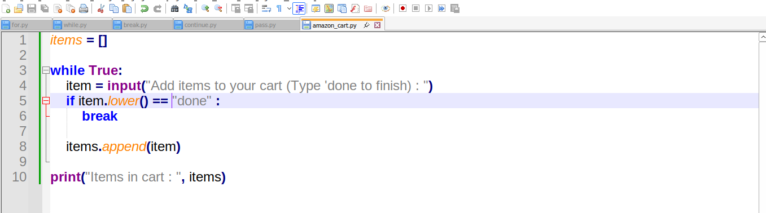

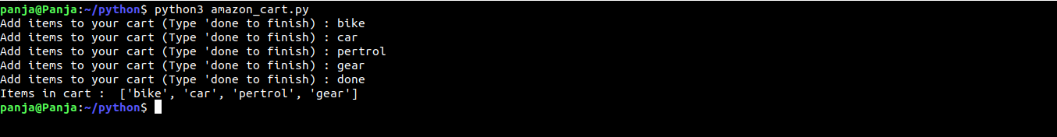
OUTPUT:

Functions:

abc() -> somethings ends with () is a function

upper() it is also a function
we can create a program and make it as a function and we can call whereever we want

reusable code is called as a function

function starts with def:

when we call the function then only it will run

example:

def great():
print("Welcome to function")

great()

🧠 What is a Function?
A function is a block of organized, reusable code that performs a specific task when called.

🔹 Why Use Functions?
✅ Reusability
✅ Code Organization
✅ Avoid Repetition (DRY: Don't Repeat Yourself)
✅ Testing becomes easier
✅ Improves Readability and Maintainability

🔧 Function Basics

🔸 Syntax
python
CopyEdit
def function_name(parameters):
# block of code
return result

🧪 Example 1: Simple Function
python
CopyEdit
def greet():
print("Hello! Welcome to Python")

greet()

🧪 Example 2: Function with Parameters
python
CopyEdit
def greet_user(name):
print(f"Hello, {name}!")

greet_user("Sarath")

🔹 Return Statement
python
CopyEdit
def add(a, b):
return a + b

result = add(10, 20)
print(result)
🔁 return ends the function and returns a value to the caller.

🧠 Types of Function Arguments

1. Positional Arguments
python
CopyEdit
def profile(name, age):
print(name, age)

profile("John", 25)

2. Default Arguments
python
CopyEdit
def profile(name, age=18):
print(name, age)

profile("John")

3. Keyword Arguments
python
CopyEdit
profile(age=30, name="Alice")

4. Variable-Length Arguments

a. *args (non-keyworded)
python
CopyEdit
def total(*numbers):
return sum(numbers)

print(total(1, 2, 3, 4))

b. **kwargs (keyworded)
python
CopyEdit
def details(**info):
print(info)

details(name="Alice", age=25)

🔄 Nested Functions
python
CopyEdit
def outer():
def inner():
print("Inner function")
inner()

outer()

🔁 Recursion (Function calling itself)
python
CopyEdit
def factorial(n):
if n == 0:
return 1
return n * factorial(n-1)

print(factorial(5)) # 120
📌 Used in tree/graph traversal, algorithms like DFS, etc.

🧪 Lambda Functions (Anonymous)
python
CopyEdit
square = lambda x: x ** 2
print(square(5))
📌 Quick one-liners, often used with map(), filter(), sorted()

⚙️ Built-in Functions vs User-Defined
- Built-in: print(), len(), sum(), max()
- User-Defined: Created using def

🧠 Real-Time Examples
- Banking System:
def calculate_interest(balance, rate): ...
- E-Commerce:
def apply_discount(cart_total): ...
- Sensor Data Logger:
def read_sensor(temp): ...

🔧 1. E-Commerce: Calculate Total Price After Discount

🧩 Problem:
An e-commerce platform needs to calculate the final price after applying a discount.
python
CopyEdit
def apply_discount(price, discount_percent):
final_price = price - (price * discount_percent / 100)
return final_price

total = apply_discount(1000, 10)
print(f"Final price: ₹{total}")
💡 Use Case: Flipkart/Meesho cart pricing calculation.

🏦 2. Banking: Interest Calculator

🧩 Problem:
Calculate yearly simple interest for a customer.
python
CopyEdit
def calculate_interest(principal, rate, time):
interest = (principal * rate * time) / 100
return interest

interest_amount = calculate_interest(50000, 5.5, 2)
print(f"Interest: ₹{interest_amount}")
💡 Use Case: Loan interest, FD interest calculators in bank apps.

🌡️ 3. IoT / Embedded Systems: Temperature Sensor Alert

🧩 Problem:
If temperature exceeds 40°C, trigger alert.
python
CopyEdit
def check_temperature(temp):
if temp > 40:
print("🔥 Alert! Overheating Detected.")
else:
print("✅ Normal Temperature")

check_temperature(42)
💡 Use Case: Microcontroller reading sensors in a manufacturing plant.

📦 4. Inventory Management: Stock Level Checker

🧩 Problem:
Check if stock is low and alert the warehouse team.
python
CopyEdit
def check_stock(item, quantity):
if quantity < 10:
print(f"⚠️ Restock needed for {item}")
else:
print(f"Stock level is fine for {item}")

check_stock("iPhone 15", 6)
💡 Use Case: Warehouse or POS system logic in retail.

🚖 5. Ride Booking App: Fare Calculator
python
CopyEdit
def calculate_fare(distance_km, rate_per_km):
return distance_km * rate_per_km

fare = calculate_fare(12, 8)
print(f"Total fare: ₹{fare}")
💡 Use Case: Ola/Uber pricing system.

🎮 6. Gaming App: Player Level Progress
python
CopyEdit
def next_level_score(current_score):
return current_score + 100

new_score = next_level_score(450)
print(f"New Target: {new_score}")
💡 Use Case: XP progression in a mobile game.

📅 7. Leave Management System: Calculate Leave Balance
python
CopyEdit
def calculate_leave_balance(total_leave, used_leave):
return total_leave - used_leave

remaining = calculate_leave_balance(24, 5)
print(f"Remaining Leave Days: {remaining}")
💡 Use Case: Office HR leave tracker.

🧮 8. Finance App: EMI Calculator
python
CopyEdit
def calculate_emi(principal, rate, months):
r = rate / (12 * 100)
emi = (principal * r * (1 + r)**months) / ((1 + r)**months - 1)
return round(emi, 2)

emi = calculate_emi(500000, 7.5, 60)
print(f"Monthly EMI: ₹{emi}")
💡 Use Case: Home loan / car loan EMI calculator.

🧠 Key Takeaway:
Functions are not just technical tools – they model real-world actions in software:
- Checking stock
- Sending alerts
- Calculating prices
- Making decisions
- Logging data

To use function from other file
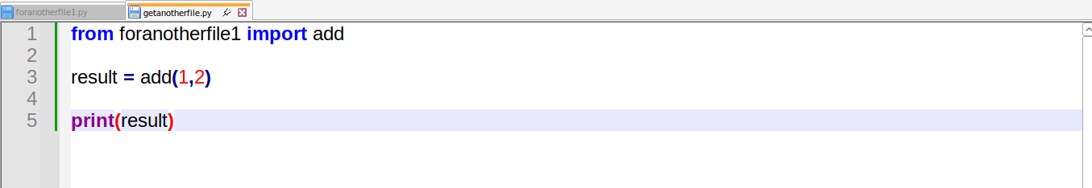
create two files

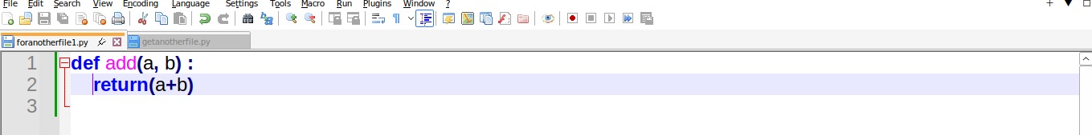
OUTPUT:
**kwargs -> it will take the input as key and values

example:
.........User Profile.............
name : Panjatcahram
age : 23
Job : Test engineer

here name is a key and panjatcharam is a value

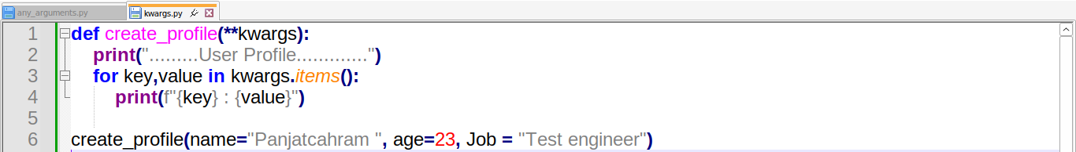
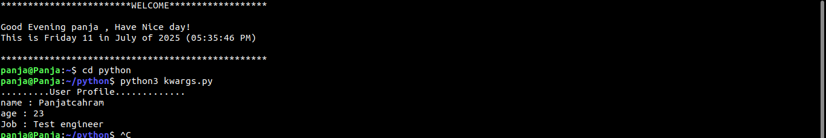
OUTPUT:

------------------------------------------------------------------------------------------------------------------------

List in python:
mutable means we can modify the list whenever we want

# Create lists for different apps

playlist = ["Beliver", "Till i collapse", "Kun fuya kun" , "Tere bina"] # Spotify

favourite_foods = ["chicken rice", "idly", "poori", "doosa"] # Zomato

recent_locations = ["home", "Office","Walaja"] # Uber

print("Spotify Playlist : " , playlist)
print("Zomato foods : ", favourite_foods)
print("Uber Locations : " ,recent_locations)

#List Methods

#Append is used to append at the last of the list

playlist.append("Aval ")
print("After append : ", playlist)

#insert

playlist.insert(1,"Your Eyes")
print("After insert : ", playlist)

# Remove

playlist.remove("Your Eyes")
print("After Removing : ", playlist)

#Pop
#it will remove the last element in the list

playlist.pop()
print("After POP: ", playlist)

#reverse

playlist.reverse()
print("After reverse : ", playlist)

#count

# It will count the number of times the word occurs

print("count : ", playlist.count("Beliver"))

#..............................................................................................................................................................................#

#List slicing

print("Top 2 songs : ",playlist[0:2]) # it will take 0 and 1 only (2 element only it will take)

print("Last 2 songs : ", playlist[-2:]) # it will show the last two element

#List Iteration:

for food in favourite_foods:
print("All foods : ", food)
for song in playlist:
print(song+" - By Gowtham")

# check if

if "doosa" in favourite_foods:
print("yes")

#Change the list element

favourite_foods[1]="Idiyappam"
print("Updated favourite_foods : ",favourite_foods)

mixed = ["Panjatcharam" , 23 ,180]

for a in mixed:
print(a)

# to get the index locations

for i, locations in enumerate(recent_locations):
print(f"locations {1} : {locations}")

OUTPUT:

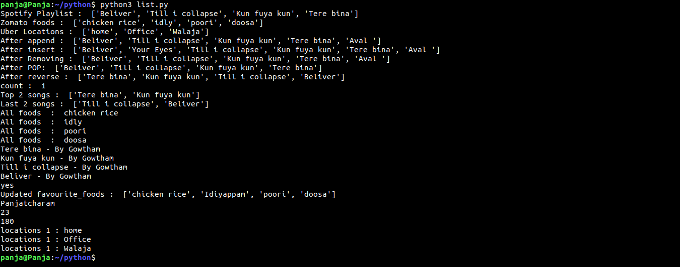

Tuples:() ->paranthesis is tuple
Tuples is immutable : it cannot remove and edit the elements
it is used in fixed logs and datas that we dont want to change and tuple is faster than list
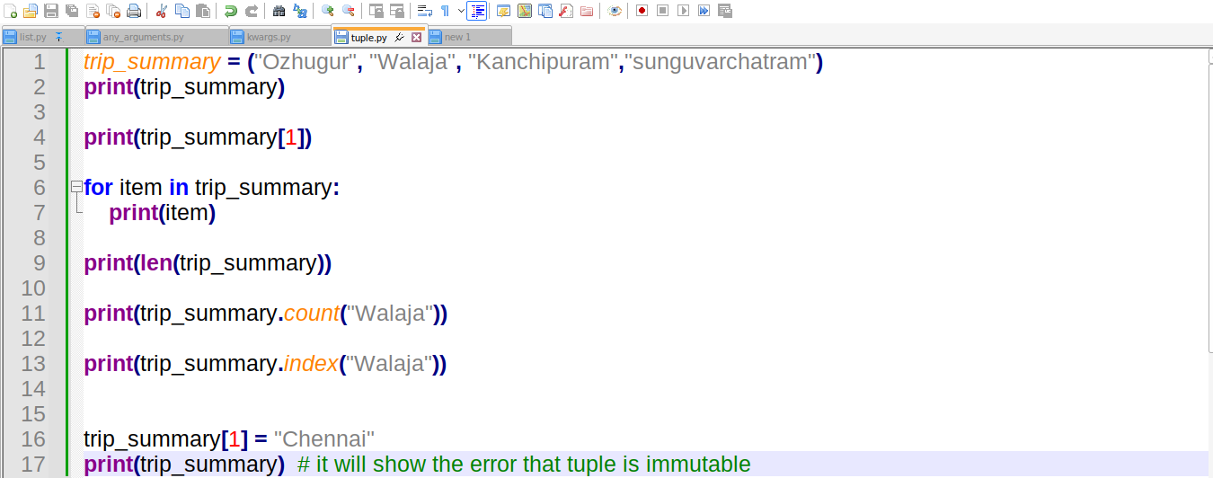
OUTPUT:
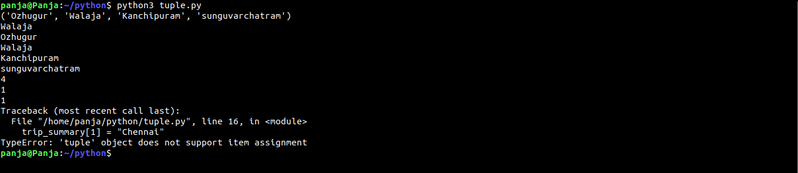
SET:{}
set is unordered and it is mutable

it will eliminate the duplicate
A set is an unordered collection of unique elements.
We cannot update it because it does not have index
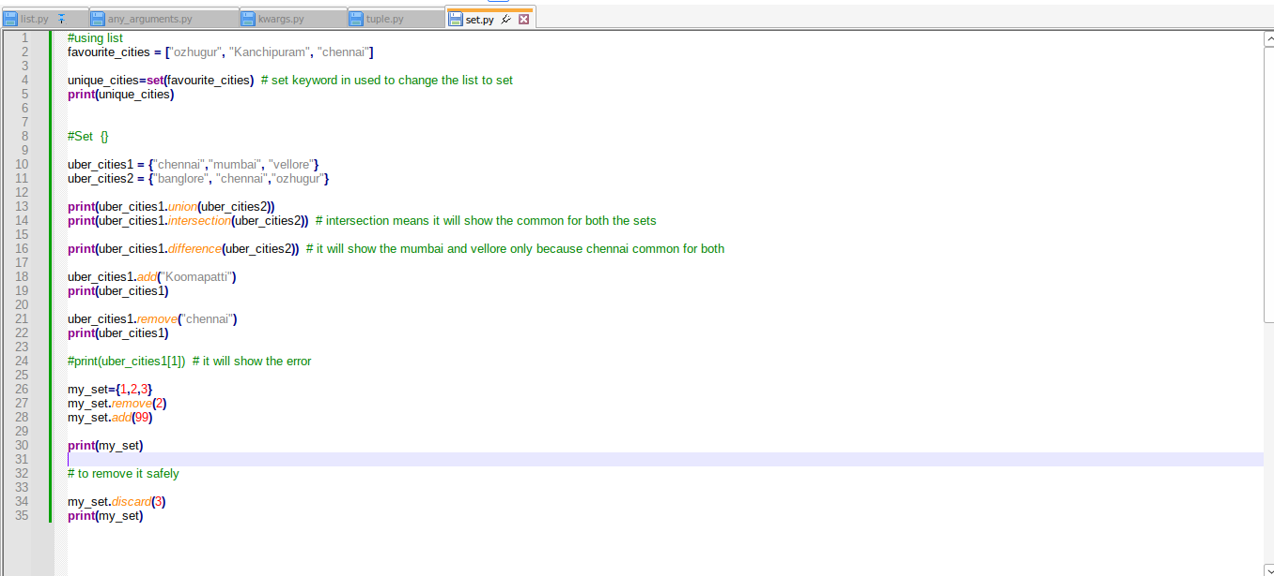

OUTPUT:

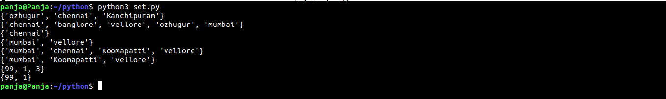
Dictionary: {}
key and values pairs it will store
name = panjatcharam
age=23
here name and age is key and panjatcharam and 23 is value

it will not allow duplicate

#Multiple dictionary

#two ways by one using list
trips = [
{"trip_id" : "UB01", "pickup" : "chennai", "drop" : "home", "fare" : "500"},
{"trip_id" : "UB02", "pickup" : "kanchipuram", "drop" : "walaja", "fare" : "200"},
{"trip_id" : "UB03", "pickup" : "chennai", "drop" : "banglore", "fare" : "600"}
]

for trip in trips:
print(trip["trip_id"])

OUTPUT:
UB01
UB02
UB03

# second method by using dictionary

but here we need to make it as a value
trips = {
"UB01": {"trip_id" : "UB01", "pickup" : "chennai", "drop" : "home", "fare" : "500"},
"UB02": {"trip_id" : "UB02", "pickup" : "kanchipuram", "drop" : "walaja", "fare" : "200"},
"UB03": {"trip_id" : "UB03", "pickup" : "chennai", "drop" : "banglore", "fare" : "600"}
}

print("UB01 Fare", trips["UB01"]["fare"])

OUTPUT:
UB01 Fare 500

#Dictionary
"""
trip = {
"trip_id" : "UB12345:",
"pickup" : "Ozhugur",
"drop" : ["Kanchipuram", "Walaja", "Chennai"],
"fare" : 200,
"driver" : "Ram",
"Status" : "Completed",
"trip_id" : "UB123456"
}

print(trip["pickup"]) # it will take it as a key
print(trip.get("Ozhugur"))

print(trip.keys())
print(trip.values())

for key, value in trip.items(): # to iterate through the dictionary
print(key, ":", value)

trip.update({"car_mode" : "Audi"}) # it will check the key is availabe it will update the value if not availble means it will add key and value
print(trip)

trip.pop("Status")
print(trip)

#duplicate check

for k, v in trip.items(): # here it will take the updated trip_id UB123456 as output it will omit the first id
print(k, ":",v)

print(trip["drop"][1]) # it will take the particular elements

for location in trip["drop"]:
print(location)

"""

#Multiple dictionary
"""
#two ways by one using list
trips = [
{"trip_id" : "UB01", "pickup" : "chennai", "drop" : "home", "fare" : "500"},
{"trip_id" : "UB02", "pickup" : "kanchipuram", "drop" : "walaja", "fare" : "200"},
{"trip_id" : "UB03", "pickup" : "chennai", "drop" : "banglore", "fare" : "600"}
]

for trip in trips:
print(trip["trip_id"])

"""
#two ways by one using it as dictionary
trips = {
"UB01": {"trip_id" : "UB01", "pickup" : "chennai", "drop" : "home", "fare" : "500"},
"UB02": {"trip_id" : "UB02", "pickup" : "kanchipuram", "drop" : "walaja", "fare" : "200"},
"UB03": {"trip_id" : "UB03", "pickup" : "chennai", "drop" : "banglore", "fare" : "600"}
}

print("UB01 Fare", trips["UB01"]["fare"])

for trip_id,details in trips.items():
print(trip_id)
print(details["pickup"],"-->", details["drop"])

Class and objects:(OOPS)

Class -> it is like a class room(table,chari,students,teacher,chalk,board all these are objects)

Method statrs with def.

Out of class def is function
inside class def is method;

function and method are two different things

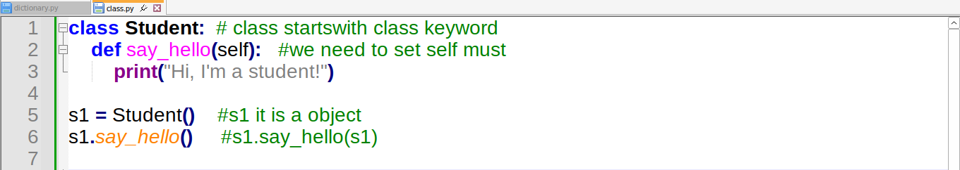

✅ What is a Class in Python?
A class is like a blueprint or template.
It defines how something should be — but it’s not the actual thing.
📦 Example: Think of a "Car Design" in a company.
- It has properties like color, speed, brand.
- And behaviors like start(), stop(), accelerate().
That Car Design is a class.

✅ What is an Object in Python?
An object is the real thing created from that blueprint.
🚗 Example: A real car like a red Hyundai or blue Tata Nexon is an object of the Car class.

💡 Python Code Example — Real Life: "Student"
Let’s say you’re in a class and you have many students. Each student has:
- A name
- A roll number
- And a method to display their details.
We’ll use a class for the blueprint, and then create student objects.
python
CopyEdit
# Define a Class
class Student:
def __init__(self, name, roll):
self.name = name # Attribute
self.roll = roll # Attribute

def show_details(self): # Method
print(f"Name: {self.name}, Roll No: {self.roll}")

# Create Objects (Real students)
student1 = Student("Panja", 101)
student2 = Student("Ravi", 102)

# Call their method
student1.show_details()
student2.show_details()

🔍 What’s Happening in Code?
Term | Meaning
class Student: | Class definition (template)
__init__ | Constructor – runs when an object is created
self | Refers to current object
student1 = Student(...) | Creating an object
student1.show_details() | Calling a method on that object

🎯 Real-World Analogy: Mobile Phone Factory
Class | Object
Phone design (class Phone) | Real phone in your hand (object)
Properties like brand, color | Your Samsung, Blue color
Methods like call(), message() | Your phone calling or messaging
python
CopyEdit
class Phone:
def __init__(self, brand, color):
self.brand = brand
self.color = color

def make_call(self):
print(f"{self.brand} is making a call...")

my_phone = Phone("Samsung", "Blue")
my_phone.make_call()

🧠 Memory Trick:
"Class is the plan, Object is the product."
Just like:
- Architect makes a house plan (Class)
- Builder builds many houses using it (Objects)

✅ Summary
Concept | Meaning
Class | Blueprint or design
Object | Real-world instance
__init__() | Constructor
self | Refers to the current object
Methods | Functions inside a class

Constructor in python:
__init__
same in class here we are using __init__ for the constructor ,it will get the data once from the object and give it to the all the members we dont have to pass it to all the members.

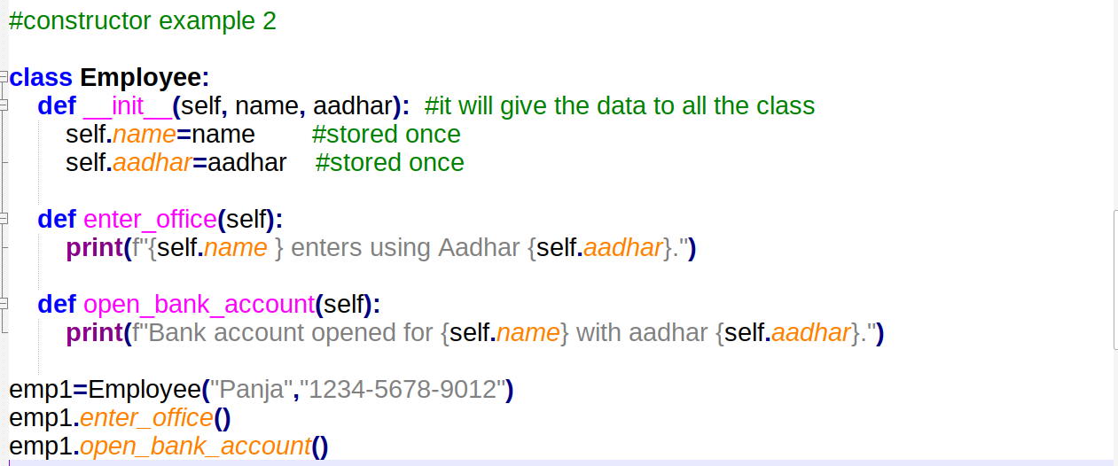

🏗️ What is a Constructor in Python?
A constructor in Python is a special method used to initialize an object when it is created.
🔧 It sets up the initial values for the object’s attributes (variables).

✅ In Python, the constructor method is:
python
CopyEdit
def __init__(self, ...):
- __init__ is a built-in method name.
- It runs automatically when you create a new object.
- self refers to the object being created.

📌 Syntax of Constructor:
python
CopyEdit
class ClassName:
def __init__(self, param1, param2):
self.param1 = param1
self.param2 = param2

🧠 Real-Life Example: Student Constructor
Let’s say every student has a name and roll number.
python
CopyEdit
class Student:
def __init__(self, name, roll):
self.name = name
self.roll = roll

def show(self):
print(f"Name: {self.name}, Roll No: {self.roll}")

# Creating an object
s1 = Student("Panja", 101)
s1.show()

🧪 Output:
yaml
CopyEdit
Name: Panja, Roll No: 101

🔄 What Happens Internally?
python
CopyEdit
s1 = Student("Panja", 101)
- Python sees you're creating an object of class Student.
- It automatically calls __init__() method.
- It passes "Panja" and 101 to it.
- Inside __init__(), it sets:
  - self.name = "Panja"
  - self.roll = 101

🧠 Memory Tip
"init" means initialize — it starts your object with values.

🎯 Constructor Types (in brief)

1. Default Constructor (no parameters except self)
python
CopyEdit
class Hello:
def __init__(self):
print("Hello constructor")

h = Hello()

2. Parameterized Constructor (takes arguments)
python
CopyEdit
class Car:
def __init__(self, brand):
self.brand = brand

c = Car("Tata")
print(c.brand) # Output: Tata

📌 Summary Table
Term | Meaning
__init__() | Constructor method in Python
self | Refers to current object
Called when? | Automatically when an object is created
Used for? | Initializing variables in the object

📌Inheretance in python:

code reusability
parent and child relation ship – normally referes as

🧬 What is Inheritance in Python?
Inheritance allows a class (Child class) to inherit the properties and methods of another class (Parent class).

🔥 Why Use Inheritance?
- Reuse existing code (DRY – Don't Repeat Yourself)
- Improve maintainability
- Create logical relationships between classes

🔧 Basic Syntax
python
CopyEdit
class Parent:
# parent members

class Child(Parent):
# child members

📘 Real-Life Analogy
Think of Father and Son:
- Father has money and house (parent properties)
- Son automatically gets access to them (inherited)
- Son can have his own things too

✅ Example: Simple Inheritance
python
CopyEdit
class Animal:
def speak(self):
print("Animals make sounds")

class Dog(Animal):
def bark(self):
print("Dog barks")

d = Dog()
d.speak() # Inherited from Animal
d.bark() # Defined in Dog

🧠 Key Concepts in Inheritance

1. Base Class / Parent Class
- The class whose properties and methods are inherited

2. Derived Class / Child Class
- The class that inherits from the parent

3. super() Function
- Used to call the constructor or methods of the parent class

🔄 Types of Inheritance in Python

1. Single Inheritance
python
CopyEdit
class A:
def show_A(self):
print("Class A")

class B(A):
def show_B(self):
print("Class B")

obj = B()
obj.show_A()
obj.show_B()

2. Multilevel Inheritance
python
CopyEdit
class A:
def show_A(self):
print("Class A")

class B(A):
def show_B(self):
print("Class B")

class C(B):
def show_C(self):
print("Class C")

obj = C()
obj.show_A()
obj.show_B()
obj.show_C()

3. Hierarchical Inheritance
python
CopyEdit
class Parent:
def greet(self):
print("Hello from Parent")

class Child1(Parent):
def child1_msg(self):
print("I'm Child 1")

class Child2(Parent):
def child2_msg(self):
print("I'm Child 2")

c1 = Child1()
c1.greet()
c1.child1_msg()

c2 = Child2()
c2.greet()
c2.child2_msg()

4. Multiple Inheritance
One child inherits from more than one parent class
python
CopyEdit
class Father:
def skills(self):
print("Cooking")

class Mother:
def traits(self):
print("Singing")

class Child(Father, Mother):
def hobby(self):
print("Dancing")

c = Child()
c.skills()
c.traits()
c.hobby()

5. Hybrid Inheritance
A combination of two or more types (like multiple + multilevel)
Python uses MRO (Method Resolution Order) to resolve conflicts when multiple parents have the same method.

🧠 super() Keyword — Deep Use

✔️ Purpose:
To call parent class constructor or method in child class
python
CopyEdit
class Person:
def __init__(self, name):
self.name = name

class Student(Person):
def __init__(self, name, roll):
super().__init__(name) # calling parent constructor
self.roll = roll

def display(self):
print(f"Name: {self.name}, Roll: {self.roll}")

s = Student("Panja", 101)
s.display()

⚠️ MRO (Method Resolution Order)
Used in multiple inheritance to decide which method Python should use if it's defined in multiple parents.
Check it with:
python
CopyEdit
print(ClassName.__mro__)

📌 Summary Table
Type | Example
Single | One parent → One child
Multilevel | A → B → C (chain)
Hierarchical | One parent → Many children
Multiple | Many parents → One child
Hybrid | Mix of above types
super() | Used to access parent methods/constructors
MRO | Handles conflicts in multiple inheritance

📘 Real-World Example: Company
python
CopyEdit
class Employee:
def work(self):
print("Working...")

class Developer(Employee):
def develop(self):
print("Developing software")

class Manager(Employee):
def manage(self):
print("Managing team")

d = Developer()
d.work()
d.develop()
